Phase 3 Semantic Analyzer



Computer Science Engineering

National Institute of Technology Karnataka, Surathkal

Date: 15 November 2023

Submitted to: Prof. Arun Prabhakar

Group Members:

1. Anant Singh [211CS104]
2. Ansh Rajvanshi [211CS106]
3. Harsh Vardhan Singh [211CS128]

**Contents**

Introduction: 3

Yacc Script 4

C Program 5

Explanation: 29

Declaration Section 29

Rules Section 30

C-Program Section 30

Test Cases: 30

Without Errors: 30

With Errors: 33

Implementation: 35

Results: 36

Valid Test Cases: 36

Invalid Test Cases 38

List of Figures and Tables:

1. **Figure 1:**​ Output for test case with variable declarations in different scopes
2. **Figure 2:** ​Output for program containing for loop, while loop, do while loop.
3. **Figure 3:** ​Output for program containing modifiers, arithmetic operators, logical operators.
4. **Figure 4:**​ Output for calling undefined function.
5. **Figure 5:**​ Output for mismatched and missing return types in function definition.
6. **Figure 6:**​ Output for function call with incorrect number of arguments.
7. **Figure 7:**​ Output for invalid condition checking.
8. **Figure 8:**​ Output for array ID out of bounds.

Abstract:

This report contains the details of the tasks finished as a part of Phase Three of Compiler Design Lab. We have developed a Parser for C language which makes use of the C lexer to parse the given C input file. In the previous submission, we were just checking if the given input code matches the language defined in the parser. We used lexer to convert the input code into a stream of tokens which was provided to the parser. Parser matches the stream with the defined productions of the language. We used look-ahead for checking errors in comments and some other lexical errors. But lexical analyser cannot detect errors in the structure of a language (syntax), unbalanced parenthesis etc. These errors were handled by a parser. But in syntax analysis phase, we don’t check if the input is semantically correct. After parser checks if the code is structured correctly, semantic analysis phase checks if that syntax structure constructed in the source program derives any meaning or not. The output of the syntax analysis phase is parse tree whereas that of semantic phase is annotated parse tree.

Semantic analysis is done by modifications in the parser code only. The following tasks are performed in semantic analysis:

1. Label Checking
2. Type Checking
3. Array Bounds Checking

# Introduction:

Semantic Analysis:

After the lexical analysis stage, we get the stream of tokens from source C code which is given as input to the parser. Parser verifies that a string of token names can be generated by the grammar of the source language. We expect the parser to check the structure of the input program and report any syntax errors. Semantic analysis phase checks the semantics of the language.

Semantics of a language provide meaning to its constructs, like tokens and syntax structure. Semantics help interpret symbols, their types, and their relations with each other. Semantic analysis judges whether the syntax structure constructed in the source program derives any meaning or not.

Semantic analysis typically involves in following tasks:

1. Type Checking – Data types are used in a manner that is consistent with their definition (i. e., only with compatible data types, only with operations that are

defined for them, etc.)

1. Label Checking – Labels references in a program must exist.
2. Array Bound Checking – When declaring an array, subscript should be defined properly.

We have mentioned some of the semantics errors that the semantic analyzer is expected to recognize:

1. Type mismatch
   1. Return type mismatch.
   2. Operations on mismatching variable types.
2. Undeclared variable
   1. Check if variable is undeclared globally.
   2. Check if variable is visible in current scope.
3. Reserved identifier misuse.
   1. Function name and variable name cannot be same.
   2. Declaration of keyword as variable name.
4. Multiple declaration of variable in a scope.
5. Accessing an out of scope variable.
6. Actual and formal parameter mismatch.

# Yacc Script

Yacc provides a general tool for describing the input to a computer program. The Yacc user specifies the structures of his input, together with code to be invoked as each such structure is recognized. Yacc turns such a specification into a subroutine that handles the input process frequently, it is convenient and appropriate to have most of the flow of control in the user's application handled by this subroutine. Lexer can be used to make a simple parser. But it needs making extensive use of the user-defined states.

The input subroutine produced by Yacc calls a user-supplied routine to return the next basic input item. Thus, the user can specify his input in terms of individual input characters, or in terms of higher-level constructs such as names and numbers. The user-supplied routine may also handle idiomatic features such as comment and continuation conventions, which typically defy easy grammatical specification.

Yacc is written in portable C. The class of specifications accepted is a very general one:

LALR(1) grammars with disambiguating rules.

The structure of our Yacc script is given below; files are divided into three sections, separated by lines that contain only two percent signs, as follows:

Definition section

**%**%​

Rules section

**%**%​

C code section

The definition section defines macros and imports header files written in C. It is also possible to write any C code here, which will be copied verbatim into the generated source file.

In the rules section, each grammar rule defines a symbol in terms of:

1. Other symbols
2. Tokens (or terminal symbols) which come from the lexer.

Each rule can have an associated action, which is executed ​*after*​ all the component symbols of the rule have been parsed. Actions are basically C-program statements surrounded by curly braces.

The C code section contains C statements and functions that are copied verbatim to the generated source file. These statements presumably contain code called by the rules in the rules section. In large programs, it is more convenient to place this code in a separate file linked in at compile time.

# C Program

This section describes the input C program which is fed to the yacc script for parsing.

The

workflow is explained as under:

1. Compile the script using Yacc tool

$ ​ ​yacc -d parser.y

1. Compile the flex script using Flex tool

$ flex scanner.l​

1. After compiling the lex file, a lex.yy.c file is generated. Also, y.tab.c and y.tab.h files are generated after compiling the yacc script.
2. The three files, lex.yy.c, y.tab.c and y.tab.h are compiled together with the options –ll and –ly

$ gcc lex.yy.c y.tab.h y.tab.c -ll -ly​

1. The executable file is generated, which on running parses the C file given as a command line input

$ ./a.out test[num].c​ or txt

The script also has an option to take standard input instead of taking input from a file.

Design of Programs:

Code:

Updated Lexer Code:

%{

#include <stdio.h>

#include <string.h>

#include "y.tab.h"

#define ANSI_COLOR_RED "\x1b[31m"

#define ANSI_COLOR_GREEN "\x1b[32m"

#define ANSI_COLOR_YELLOW "\x1b[33m"

#define ANSI_COLOR_BLUE "\x1b[34m"

#define ANSI_COLOR_MAGENTA "\x1b[35m"

#define ANSI_COLOR_CYAN "\x1b[36m"

#define ANSI_COLOR_RESET "\x1b[0m"

struct symboltable

{

char name[100];

char class[100];

char type[100];

char value[100];

int nestval;

int lineno;

int length;

int params_count;

}ST[1001];

struct constanttable

{

char name[100];

char type[100];

int length;

}CT[1001];

int currnest = 0;

int params_count = 0;

extern int yylval;

int flag;

int hash(char *str)

{

int value = 0;

for(int i = 0 ; i < strlen(str) ; i++)

{

value = 10*value + (str[i] - 'A');

value = value % 1001;

while(value < 0)

value = value + 1001;

}

return value;

}

int lookupST(char *str)

{

int value = hash(str);

if(ST[value].length == 0)

{

return 0;

}

else if(strcmp(ST[value].name,str)==0)

{

return value;

}

else

{

for(int i = value + 1 ; i!=value ; i = (i+1)%1001)

{

if(strcmp(ST[i].name,str)==0)

{

return i;

}

}

return 0;

}

}

int lookupCT(char *str)

{

int value = hash(str);

if(CT[value].length == 0)

return 0;

else if(strcmp(CT[value].name,str)==0)

return 1;

else

{

for(int i = value + 1 ; i!=value ; i = (i+1)%1001)

{

if(strcmp(CT[i].name,str)==0)

{

return 1;

}

}

return 0;

}

}

void insertSTline(char *str1, int line)

{

for(int i = 0 ; i < 1001 ; i++)

{

if(strcmp(ST[i].name,str1)==0)

{

ST[i].lineno = line;

}

}

}

void insertST(char *str1, char *str2)

{

if(lookupST(str1))

{

if(strcmp(ST[lookupST(str1)].class,"Identifier")==0 && strcmp(str2,"Array Identifier")==0)

{

printf("Error use of array\n");

exit(0);

}

return;

}

else

{

int value = hash(str1);

if(ST[value].length == 0)

{

strcpy(ST[value].name,str1);

strcpy(ST[value].class,str2);

ST[value].length = strlen(str1);

ST[value].nestval = 9999;

ST[value].params_count = -1;

insertSTline(str1,yylineno);

return;

}

int pos = 0;

for (int i = value + 1 ; i!=value ; i = (i+1)%1001)

{

if(ST[i].length == 0)

{

pos = i;

break;

}

}

strcpy(ST[pos].name,str1);

strcpy(ST[pos].class,str2);

ST[pos].length = strlen(str1);

ST[pos].nestval = 9999;

ST[pos].params_count = -1;

}

}

void insertSTtype(char *str1, char *str2)

{

for(int i = 0 ; i < 1001 ; i++)

{

if(strcmp(ST[i].name,str1)==0)

{

strcpy(ST[i].type,str2);

}

}

}

void insertSTvalue(char *str1, char *str2)

{

for(int i = 0 ; i < 1001 ; i++)

{

if(strcmp(ST[i].name,str1)==0 && ST[i].nestval == currnest)

{

strcpy(ST[i].value,str2);

}

}

}

void insertSTnest(char *s, int nest)

{

if(lookupST(s) && ST[lookupST(s)].nestval != 9999)

{

int pos = 0;

int value = hash(s);

for (int i = value + 1 ; i!=value ; i = (i+1)%1001)

{

if(ST[i].length == 0)

{

pos = i;

break;

}

}

strcpy(ST[pos].name,s);

strcpy(ST[pos].class,"Identifier");

ST[pos].length = strlen(s);

ST[pos].nestval = nest;

ST[pos].params_count = -1;

ST[pos].lineno = yylineno;

}

else

{

for(int i = 0 ; i < 1001 ; i++)

{

if(strcmp(ST[i].name,s)==0 )

{

ST[i].nestval = nest;

}

}

}

}

void insertSTparamscount(char *s, int count)

{

for(int i = 0 ; i < 1001 ; i++)

{

if(strcmp(ST[i].name,s)==0 )

{

ST[i].params_count = count;

}

}

}

int getSTparamscount(char *s)

{

for(int i = 0 ; i < 1001 ; i++)

{

if(strcmp(ST[i].name,s)==0 )

{

return ST[i].params_count;

}

}

return -2;

}

void insertSTF(char *s)

{

for(int i = 0 ; i < 1001 ; i++)

{

if(strcmp(ST[i].name,s)==0 )

{

strcpy(ST[i].class,"Function");

return;

}

}

}

void insertCT(char *str1, char *str2)

{

if(lookupCT(str1))

return;

else

{

int value = hash(str1);

if(CT[value].length == 0)

{

strcpy(CT[value].name,str1);

strcpy(CT[value].type,str2);

CT[value].length = strlen(str1);

return;

}

int pos = 0;

for (int i = value + 1 ; i!=value ; i = (i+1)%1001)

{

if(CT[i].length == 0)

{

pos = i;

break;

}

}

strcpy(CT[pos].name,str1);

strcpy(CT[pos].type,str2);

CT[pos].length = strlen(str1);

}

}

void deletedata (int nesting)

{

for(int i = 0 ; i < 1001 ; i++)

{

if(ST[i].nestval == nesting)

{

ST[i].nestval = 99999;

}

}

}

int checkscope(char *s)

{

flag=0;

for(int i = 0 ; i < 1000 ; i++)

{

if(strcmp(ST[i].name,s)==0)

{

if(ST[i].nestval > currnest)

{

flag = 1;

}

else

{

flag = 0;

break;

}

}

}

if(!flag)

{

return 1;

}

else

{

return 0;

}

}

int check_id_is_func(char *s)

{

for(int i = 0 ; i < 1000 ; i++)

{

if(strcmp(ST[i].name,s)==0)

{

if(strcmp(ST[i].class,"Function")==0)

return 1;

}

}

return 0;

}

int checkarray(char *s)

{

for(int i = 0 ; i < 1000 ; i++)

{

if(strcmp(ST[i].name,s)==0)

{

if(strcmp(ST[i].class,"Array Identifier")==0)

{

return 0;

}

}

}

return 1;

}

int duplicate(char *s)

{

for(int i = 0 ; i < 1000 ; i++)

{

if(strcmp(ST[i].name,s)==0)

{

if(ST[i].nestval == currnest)

{

return 1;

}

}

}

return 0;

}

int check_duplicate(char* str)

{

for(int i=0; i<1001; i++)

{

if(strcmp(ST[i].name, str) == 0 && strcmp(ST[i].class, "Function") == 0)

{

printf("Function redeclaration not allowed\n");

exit(0);

}

}

}

int check_declaration(char* str, char *check_type)

{

for(int i=0; i<1001; i++)

{

if(strcmp(ST[i].name, str) == 0 && strcmp(ST[i].class, "Function") == 0 || strcmp(ST[i].name,"printf")==0 )

{

return 1;

}

}

return 0;

}

int check_params(char* type_specifier)

{

if(!strcmp(type_specifier, "void"))

{

printf("Parameters cannot be of type void\n");

exit(0);

}

return 0;

}

char gettype(char *s, int flag)

{

for(int i = 0 ; i < 1001 ; i++ )

{

if(strcmp(ST[i].name,s)==0)

{

return ST[i].type[0];

}

}

}

void printST()

{

printf("%10s | %15s | %10s | %10s | %10s | %15s | %10s |\n","SYMBOL", "CLASS", "TYPE","VALUE", "LINE NO", "NESTING", "PARAMS COUNT");

for(int i=0;i<100;i++) {

printf("-");

}

printf("\n");

for(int i = 0 ; i < 1001 ; i++)

{

if(ST[i].length == 0)

{

continue;

}

printf("%10s | %15s | %10s | %10s | %10d | %15d | %10d |\n",ST[i].name, ST[i].class, ST[i].type, ST[i].value, ST[i].lineno, ST[i].nestval, ST[i].params_count);

}

}

void printCT()

{

printf("%10s | %15s\n","NAME", "TYPE");

for(int i=0;i<81;i++) {

printf("-");

}

printf("\n");

for(int i = 0 ; i < 1001 ; i++)

{

if(CT[i].length == 0)

continue;

printf("%10s | %15s\n",CT[i].name, CT[i].type);

}

}

char curid[20];

char curtype[20];

char curval[20];

%}

DE "define"

IN "include"

%%

\n {yylineno++;}

([#][" "]*({IN})[ ]*([<]?)([A-Za-z]+)[.]?([A-Za-z]*)([>]?))/["\n"|\/|" "|"\t"] { }

([#][" "]*({DE})[" "]*([A-Za-z]+)(" ")*[0-9]+)/["\n"|\/|" "|"\t"] { }

\/\/(.*) { }

\/\*([^*]|[\r\n]|(\*+([^*/]|[\r\n])))*\*+\/ { }

[ \n\t] ;

";" { return(';'); }

"," { return(','); }

("{") { return('{'); }

("}") { return('}'); }

"(" { return('('); }

")" { return(')'); }

("["|"<:") { return('['); }

("]"|":>") { return(']'); }

":" { return(':'); }

"." { return('.'); }

"char" { strcpy(curtype,yytext); insertST(yytext, "Keyword");return CHAR;}

"double" { strcpy(curtype,yytext); insertST(yytext, "Keyword"); return DOUBLE;}

"else" { insertST(yytext, "Keyword"); return ELSE;}

"float" { strcpy(curtype,yytext); insertST(yytext, "Keyword"); return FLOAT;}

"while" { insertST(yytext, "Keyword"); return WHILE;}

"do" { insertST(yytext, "Keyword"); return DO;}

"for" { insertST(yytext, "Keyword"); return FOR;}

"if" { insertST(yytext, "Keyword"); return IF;}

"int" { strcpy(curtype,yytext); insertST(yytext, "Keyword"); return INT;}

"long" { strcpy(curtype,yytext); insertST(yytext, "Keyword"); return LONG;}

"return" { insertST(yytext, "Keyword"); return RETURN;}

"short" { strcpy(curtype,yytext); insertST(yytext, "Keyword"); return SHORT;}

"signed" { strcpy(curtype,yytext); insertST(yytext, "Keyword"); return SIGNED;}

"sizeof" { insertST(yytext, "Keyword"); return SIZEOF;}

"struct" { strcpy(curtype,yytext); insertST(yytext, "Keyword"); return STRUCT;}

"unsigned" { insertST(yytext, "Keyword"); return UNSIGNED;}

"void" { strcpy(curtype,yytext); insertST(yytext, "Keyword"); return VOID;}

"break" { insertST(yytext, "Keyword"); return BREAK;}

"++" { return increment_operator; }

"--" { return decrement_operator; }

"<<" { return leftshift_operator; }

">>" { return rightshift_operator; }

"<=" { return lessthan_assignment_operator; }

"<" { return lessthan_operator; }

">=" { return greaterthan_assignment_operator; }

">" { return greaterthan_operator; }

"==" { return equality_operator; }

"!=" { return inequality_operator; }

"&&" { return AND_operator; }

"||" { return OR_operator; }

"^" { return caret_operator; }

"*=" { return multiplication_assignment_operator; }

"/=" { return division_assignment_operator; }

"%=" { return modulo_assignment_operator; }

"+=" { return addition_assignment_operator; }

"-=" { return subtraction_assignment_operator; }

"<<=" { return leftshift_assignment_operator; }

">>=" { return rightshift_assignment_operator; }

"&=" { return AND_assignment_operator; }

"^=" { return XOR_assignment_operator; }

"|=" { return OR_assignment_operator; }

"&" { return amp_operator; }

"!" { return exclamation_operator; }

"~" { return tilde_operator; }

"-" { return subtract_operator; }

"+" { return add_operator; }

"*" { return multiplication_operator; }

"/" { return division_operator; }

"%" { return modulo_operator; }

"|" { return pipe_operator; }

\= { return assignment_operator;}

\"[^\n]*\"/[;|,|\)] {strcpy(curval,yytext); insertCT(yytext,"String Constant"); return string_constant;}

\'[A-Z|a-z]\'/[;|,|\)|:] {strcpy(curval,yytext); insertCT(yytext,"Character Constant"); return character_constant;}

[a-z|A-Z]([a-z|A-Z]|[0-9])*/\[ {strcpy(curid,yytext); insertST(yytext, "Array Identifier"); return array_identifier;}

[1-9][0-9]*|0/[;|,|" "|\)|<|>|=|\!|\||&|\+|\-|\*|\/|\%|~|\]|\}|:|\n|\t|\^] {strcpy(curval,yytext); insertCT(yytext, "Number Constant"); yylval = atoi(yytext); return integer_constant;}

([0-9]*)\.([0-9]+)/[;|,|" "|\)|<|>|=|\!|\||&|\+|\-|\*|\/|\%|~|\n|\t|\^] {strcpy(curval,yytext); insertCT(yytext, "Floating Constant"); return float_constant;}

[A-Za-z_][A-Za-z_0-9]* {strcpy(curid,yytext); insertST(curid,"Identifier"); return identifier;}

(.?) {

if(yytext[0]=='#')

{

printf("Error in Pre-Processor directive at line no. %d\n",yylineno);

}

else if(yytext[0]=='/')

{

printf("ERR_UNMATCHED_COMMENT at line no. %d\n",yylineno);

}

else if(yytext[0]=='"')

{

printf("ERR_INCOMPLETE_STRING at line no. %d\n",yylineno);

}

else

{

printf("ERROR at line no. %d\n",yylineno);

}

printf("%s\n", yytext);

return 0;

}

%%

int yywrap(){

return 1;

}

Parser Code:

%{

void yyerror(char* s);

int yylex();

int yyparse();

#include "stdio.h"

#include "stdlib.h"

#include "ctype.h"

#include "string.h"

void ins();

void insV();

#define ANSI_COLOR_RED "\x1b[31m"

#define ANSI_COLOR_GREEN "\x1b[32m"

#define ANSI_COLOR_CYAN "\x1b[36m"

#define ANSI_COLOR_RESET "\x1b[0m"

extern int flag=0;

extern char curid[20];

extern char curtype[20];

extern char curval[20];

extern int currnest;

void deletedata (int );

int checkscope(char*);

int check_id_is_func(char *);

void insertST(char*, char*);

void insertSTnest(char*, int);

void insertSTparamscount(char*, int);

int getSTparamscount(char*);

int check_duplicate(char*);

int check_declaration(char*, char *);

int check_params(char*);

int duplicate(char *s);

int checkarray(char*);

char currfunctype[100];

char currfunc[100];

char currfunccall[100];

void insertSTF(char*);

char gettype(char*,int);

char getfirst(char*);

extern int params_count;

int call_params_count;

%}

%nonassoc IF

%token INT CHAR FLOAT DOUBLE LONG SHORT SIGNED UNSIGNED STRUCT

%token RETURN MAIN

%token VOID

%token WHILE FOR DO

%token BREAK

%token ENDIF

%expect 1

%token identifier array_identifier func_identifier

%token integer_constant string_constant float_constant character_constant

%nonassoc ELSE

%right leftshift_assignment_operator rightshift_assignment_operator

%right XOR_assignment_operator OR_assignment_operator

%right AND_assignment_operator modulo_assignment_operator

%right multiplication_assignment_operator division_assignment_operator

%right addition_assignment_operator subtraction_assignment_operator

%right assignment_operator

%left OR_operator

%left AND_operator

%left pipe_operator

%left caret_operator

%left amp_operator

%left equality_operator inequality_operator

%left lessthan_assignment_operator lessthan_operator greaterthan_assignment_operator greaterthan_operator

%left leftshift_operator rightshift_operator

%left add_operator subtract_operator

%left multiplication_operator division_operator modulo_operator

%right SIZEOF

%right tilde_operator exclamation_operator

%left increment_operator decrement_operator

%start program

%%

program

: declaration_list;

declaration_list

: declaration D

D

: declaration_list

| ;

declaration

: variable_declaration

| function_declaration

variable_declaration

: type_specifier variable_declaration_list ';'

variable_declaration_list

: variable_declaration_list ',' variable_declaration_identifier | variable_declaration_identifier;

variable_declaration_identifier

: identifier {if(duplicate(curid)){printf("Duplicate\n");exit(0);}insertSTnest(curid,currnest); ins(); } vdi

| array_identifier {if(duplicate(curid)){printf("Duplicate\n");exit(0);}insertSTnest(curid,currnest); ins(); } vdi;

vdi : identifier_array_type | assignment_operator simple_expression ;

identifier_array_type

: '[' initilization_params

| ;

initilization_params

: integer_constant ']' initilization {if($$ < 1) {printf("Wrong array size\n"); exit(0);} }

| ']' string_initilization;

initilization

: string_initilization

| array_initialization

| ;

type_specifier

: INT | CHAR | FLOAT | DOUBLE

| LONG long_grammar

| SHORT short_grammar

| UNSIGNED unsigned_grammar

| SIGNED signed_grammar

| VOID ;

unsigned_grammar

: INT | LONG long_grammar | SHORT short_grammar | ;

signed_grammar

: INT | LONG long_grammar | SHORT short_grammar | ;

long_grammar

: INT | ;

short_grammar

: INT | ;

function_declaration

: function_declaration_type function_declaration_param_statement;

function_declaration_type

: type_specifier identifier '(' { strcpy(currfunctype, curtype); strcpy(currfunc, curid); check_duplicate(curid); insertSTF(curid); ins(); };

function_declaration_param_statement

: params ')' statement;

params

: parameters_list | ;

parameters_list

: type_specifier { check_params(curtype); } parameters_identifier_list { insertSTparamscount(currfunc, params_count); };

parameters_identifier_list

: param_identifier parameters_identifier_list_breakup;

parameters_identifier_list_breakup

: ',' parameters_list

| ;

param_identifier

: identifier { ins();insertSTnest(curid,1); params_count++; } param_identifier_breakup;

param_identifier_breakup

: '[' ']'

| ;

statement

: expression_statment | compound_statement

| conditional_statements | iterative_statements

| return_statement | break_statement

| variable_declaration;

compound_statement

: {currnest++;} '{' statment_list '}' {deletedata(currnest);currnest--;} ;

statment_list

: statement statment_list

| ;

expression_statment

: expression ';'

| ';' ;

conditional_statements

: IF '(' simple_expression ')' {if($3!=1){printf("Condition checking is not of type int\n");exit(0);}} statement conditional_statements_breakup;

conditional_statements_breakup

: ELSE statement

| ;

iterative_statements

: WHILE '(' simple_expression ')' {if($3!=1){printf("Condition checking is not of type int\n");exit(0);}} statement

| FOR '(' expression ';' simple_expression ';' {if($5!=1){printf("Condition checking is not of type int\n");exit(0);}} expression ')'

| DO statement WHILE '(' simple_expression ')'{if($5!=1){printf("Condition checking is not of type int\n");exit(0);}} ';';

return_statement

: RETURN ';' {if(strcmp(currfunctype,"void")) {printf("Returning void of a non-void function\n"); exit(0);}}

| RETURN expression ';' { if(!strcmp(currfunctype, "void"))

{

yyerror("Function is void");

}

if((currfunctype[0]=='i' || currfunctype[0]=='c') && $2!=1)

{

printf("Expression doesn't match return type of function\n"); exit(0);

}

};

break_statement

: BREAK ';' ;

string_initilization

: assignment_operator string_constant {insV();} ;

array_initialization

: assignment_operator '{' array_int_declarations '}';

array_int_declarations

: integer_constant array_int_declarations_breakup;

array_int_declarations_breakup

: ',' array_int_declarations

| ;

expression

: mutable assignment_operator expression {

if($1==1 && $3==1)

{

$$=1;

}

else

{$$=-1; printf("Type mismatch\n"); exit(0);}

}

| mutable addition_assignment_operator expression {

if($1==1 && $3==1)

$$=1;

else

{$$=-1; printf("Type mismatch\n"); exit(0);}

}

| mutable subtraction_assignment_operator expression {

if($1==1 && $3==1)

$$=1;

else

{$$=-1; printf("Type mismatch\n"); exit(0);}

}

| mutable multiplication_assignment_operator expression {

if($1==1 && $3==1)

$$=1;

else

{$$=-1; printf("Type mismatch\n"); exit(0);}

}

| mutable division_assignment_operator expression {

if($1==1 && $3==1)

$$=1;

else

{$$=-1; printf("Type mismatch\n"); exit(0);}

}

| mutable modulo_assignment_operator expression {

if($1==1 && $3==1)

$$=1;

else

{$$=-1; printf("Type mismatch\n"); exit(0);}

}

| mutable increment_operator {if($1 == 1) $$=1; else $$=-1;}

| mutable decrement_operator {if($1 == 1) $$=1; else $$=-1;}

| simple_expression {if($1 == 1) $$=1; else $$=-1;} ;

simple_expression

: simple_expression OR_operator and_expression {if($1 == 1 && $3==1) $$=1; else $$=-1;}

| and_expression {if($1 == 1) $$=1; else $$=-1;};

and_expression

: and_expression AND_operator unary_relation_expression {if($1 == 1 && $3==1) $$=1; else $$=-1;}

|unary_relation_expression {if($1 == 1) $$=1; else $$=-1;} ;

unary_relation_expression

: exclamation_operator unary_relation_expression {if($2==1) $$=1; else $$=-1;}

| regular_expression {if($1 == 1) $$=1; else $$=-1;} ;

regular_expression

: regular_expression relational_operators sum_expression {if($1 == 1 && $3==1) $$=1; else $$=-1;}

| sum_expression {if($1 == 1) $$=1; else $$=-1;} ;

relational_operators

: greaterthan_assignment_operator | lessthan_assignment_operator | greaterthan_operator

| lessthan_operator | equality_operator | inequality_operator ;

sum_expression

: sum_expression sum_operators term {if($1 == 1 && $3==1) $$=1; else $$=-1;}

| term {if($1 == 1) $$=1; else $$=-1;};

sum_operators

: add_operator

| subtract_operator ;

term

: term MULOP factor {if($1 == 1 && $3==1) $$=1; else $$=-1;}

| factor {if($1 == 1) $$=1; else $$=-1;} ;

MULOP

: multiplication_operator | division_operator | modulo_operator ;

factor

: immutable {if($1 == 1) $$=1; else $$=-1;}

| mutable {if($1 == 1) $$=1; else $$=-1;} ;

mutable

: identifier {

if(check_id_is_func(curid))

{printf("Function name used as Identifier\n"); exit(8);}

if(!checkscope(curid))

{printf("%s\n",curid);printf("Undeclared\n");exit(0);}

if(!checkarray(curid))

{printf("%s\n",curid);printf("Array ID has no subscript\n");exit(0);}

if(gettype(curid,0)=='i' || gettype(curid,1)== 'c')

$$ = 1;

else

$$ = -1;

}

| array_identifier {if(!checkscope(curid)){printf("%s\n",curid);printf("Undeclared\n");exit(0);}} '[' expression ']'

{if(gettype(curid,0)=='i' || gettype(curid,1)== 'c')

$$ = 1;

else

$$ = -1;

};

immutable

: '(' expression ')' {if($2==1) $$=1; else $$=-1;}

| call

| constant {if($1==1) $$=1; else $$=-1;};

call

: identifier '('{

if(!check_declaration(curid, "Function"))

{ printf("Function not declared"); exit(0);}

insertSTF(curid);

strcpy(currfunccall,curid);

} arguments ')'

{ if(strcmp(currfunccall,"printf"))

{

if(getSTparamscount(currfunccall)!=call_params_count)

{

yyerror("Number of arguments in function call doesn't match number of parameters");

//printf("Number of arguments in function call %s doesn't match number of parameters\n", currfunccall);

exit(8);

}

}

};

arguments

: arguments_list | ;

arguments_list

: expression { call_params_count++; } A ;

A

: ',' expression { call_params_count++; } A

| ;

constant

: integer_constant { insV(); $$=1; }

| string_constant { insV(); $$=-1;}

| float_constant { insV(); }

| character_constant{ insV();$$=1; };

%%

extern FILE *yyin;

extern int yylineno;

extern char *yytext;

void insertSTtype(char *,char *);

void insertSTvalue(char *, char *);

void incertCT(char *, char *);

void printST();

void printCT();

int main(int argc , char **argv)

{

yyin = fopen(argv[1], "r");

yyparse();

if(flag == 0)

{

printf(ANSI_COLOR_GREEN "Status: Parsing Complete - Valid" ANSI_COLOR_RESET "\n");

printf("%30s" ANSI_COLOR_CYAN "SYMBOL TABLE" ANSI_COLOR_RESET "\n", " ");

printf("%30s %s\n", " ", "------------");

printST();

printf("\n\n%30s" ANSI_COLOR_CYAN "CONSTANT TABLE" ANSI_COLOR_RESET "\n", " ");

printf("%30s %s\n", " ", "--------------");

printCT();

}

}

void yyerror(char *s)

{

printf(ANSI_COLOR_RED "%d %s %s\n", yylineno, s, yytext);

flag=1;

printf(ANSI_COLOR_RED "Status: Parsing Failed - Invalid\n" ANSI_COLOR_RESET);

exit(7);

}

void ins()

{

insertSTtype(curid,curtype);

}

void insV()

{

insertSTvalue(curid,curval);

}

# Explanation:

The lex code is detecting the tokens from the source code and returning the corresponding token to the parser. In phase 1 we were just printing the token and now we are returning the token so that parser uses it for further computation. We are using

the symbol table and constant table of the previous phase only. We added functions like

insertSTnest(),insertSTparamscount(),checkscope(),deletedata(),d uplicate() ​etc., in order to check the semantics.​ ​In the production rules of the grammar semantic actions are written and these are performed by the functions listed above.

## Declaration Section

In this section we have included all the necessary header files,function declaration and flag that was needed in the code.

Between declaration and rules section we have listed all the tokens which are returned by the lexer according to the precedence order. We also declared the operators here according to their associativity and precedence.This ensures the grammar we are giving to the parser is unambiguous as LALR(1) parser cannot work with ambiguous grammar.

## Rules Section

In this section production rules for entire C language is written. The grammar productions does the syntax analysis of the source code. When a complete statement with proper syntax is matched by the parser. Along with rules semantic actions associated with the rules are also written and corresponding functions are called to do the necessary actions.

## C-Program Section

In this section the parser links the extern functions,variables declared in the lexer, external files generated by the lexer etc. The main function takes the input source code file and prints the final symbol table.

# Test Cases:

## Without Errors:

**Test Case 1**

**//Multiple declaration of variable in different scope**

|  |
| --- |
| **#include<stdio.h>**    **int**​ ​**myfunc**​(​**int**​ b)  {  **int**​ x; x = b; **return**​ x;  }  **void**​ ​**main**​()  { **int**​ n,i; **int**​ x;  **for**​ (i=​0​;i<n;i++){  **if**​(i<​n​){  **int**​ x;  **while**​(x<​n​){  **int**​ x;  x++;  }  }  } x++;  } |

Test Case 2

|  |  |
| --- | --- |
| ***//for loop***  ***//while loop***  ***//do while loop***    **#include<stdio.h>**  **int** ​**main**​**()**  **{ int a=**​**0**​**; for (a =** ​**0**​**; a <** ​**10**​**; a++)**  **{**  ​**printf**​**(**​**"H1"**​**);** | |
| **}** | **}**  **while(a>**​**0**​**) { a--; }**  **do { a++;**  **}while(a<**​**10**​**);** |

Test Case 3:

|  |
| --- |
| ***//modifiers***  ***//arithmetic operation***  ***//logical operations***    **#include<stdio.h> int** ​**main**​**()**  **{ long int a, b; unsigned long int x; signed short int y; signed short z; int w;**  **a =** ​**23**​**; b =** ​**15**​**; int c = a + b; printf**​**(**​**"%d"**​**,c); c = a - b; printf**​**(**​**"%d"**​**,c); c = a * b; printf**​**(**​**"%d"**​**,c); c = a/b; printf**​**(**​**"%d"**​**,c); c = a%b;**  **printf**​**(**​**"%d"**​**,c);**  **c = (a>=b); printf**​**(**​**"%d"**​**,c); c = (a<=b);** |
| **printf**​**(**​**"%d"**​**,c); c = (a==b); printf**​**(**​**"%d"**​**,c); c = (a!=b); printf**​**(**​**"%d"**​**,c);**  **}** |

## With Errors:

Test Case 1:

|  |
| --- |
| ***// Undeclared function***  **#include<stdio.h>**  **void main**​ **()**​  **{ int i,n; myfunc(i);**  **}** |

Test Case 2:

|  |
| --- |
| ***// Function of type void but still returning***  ***#include<stdio.h>***    ***void***​​***myfunc***​*(*​***int***​ *a)*  *{* ***return***​ *a;*  *}*  ***void***​​***main***​*()*  *{*  ***int***​ *i,n;*  *myfunc(i);*  *}* |

Test Case 3:

***// Wrong number of arguments for the function***

***#include<stdio.h>***

|  |
| --- |
| ***int***​​***myfunc***​*(*​***int***​ *a)*  *{* ***return***​ *a;*  *}*  ***void***​​***main***​*()*  *{* ***int***​ *i,n; myfunc(i,n);*  *}* |

Test Case 4:

|  |
| --- |
| **//Invalid condition checking**  **#include<stdio.h> void** ​**main**​**()**  **{ int x,i; if(**​**"str"**​**)**  **{ x=**​**1**​**;**  **} else**  **{ x=**​**3**​**;**  **}**  **}** |

Test Case 5:

|  |
| --- |
| **// Array of size 0**  **#include<stdio.h>**    **void**​ ​**main**​()  {  **int**​ a[​0​];  } |

# Implementation:

The lexer code submitted in the previous phase took care of most of the features of C using regular expressions. Some special corner cases were taken care of using custom regex. These were:

1. The Regex for Identifiers
2. Multiline comments should be supported
3. Literals
4. Error Handling for Incomplete String
5. Error Handling for Nested Comments

The parser code requires exhaustive token recognition and because of this reason, we utilised the lexer code given under the C specifications with the parser. The parser

implements C grammar using a number of production rules.

The parser takes tokens from the lexer output, one at a time and applies the corresponding production rules to append to the symbol table with type , value and line of declaration. If the parsing is not successful, the parser outputs the line number with the corresponding error. Along with this semantic actions were also added to each production rule to check if the structure created has some meaning or not. The following functions were written in order to check semantics:

1. insertSTnest() - ​ ​This function was used to insert the nesting value of an identifier to the symbol table.

2.insertSTparamscount() - ​ ​Inserts the count of number of parameters for a function

3.getSTparamscount()-​​Get the number of parameters in a function

4.deletedata() - ​ This function deletes the data when its scope is over.​

5.checkscope() - ​ ​It checks whether the identifier is declared in the current scope or not.

6.check_id_is_func()-​​Check if the identifier is declared as a function or not.

7.checkarray() - ​ ​It checks whether the identifier is of array data type or not. If yes it returns true else false.

8.duplicate()-​​It checks if the identifier was already declared or not.

9.check_duplicate()​ ​- It checks if the function is re-declared or not.

1. check_declaration()​ ​- It checks if the function is declared or not,
2. check_params()-​​it checks whether the parameters used in function definition are not of type void.
3. char gettype() - ​ ​it returns the first char of the data type of identifier.

# Results:

We were able to successfully parse the tokens recognized by the flex script for C. The output displays the set of identifiers and constants present in the program with their types,values and line of declaration. Also nesting values changes dynamically as the program ends its made infinite. The parser generates error messages in case of any syntactical errors in the test program or any semantic error.

## Valid Test Cases:

Test Case 1: O​perator, Nested loops, Delimiters, Function, Assignments,

Conditional Statements

Output:

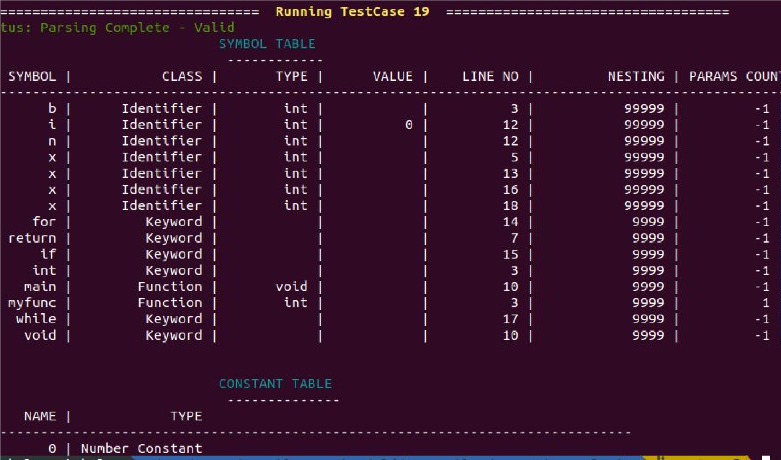

Fig. 1

**Status: Pass**

Test Case 2: Loop Statements

Output:

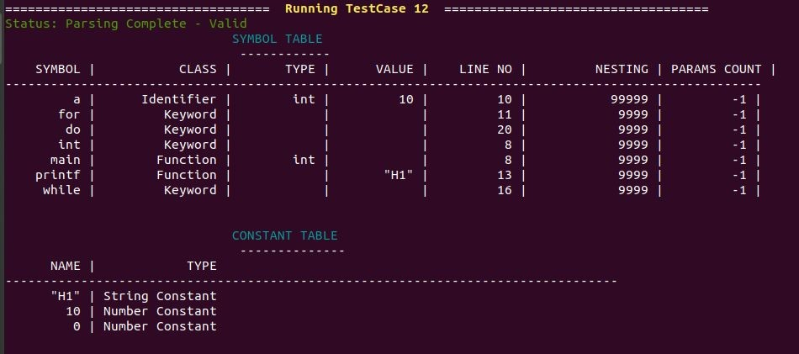

Fig. 2

**Status : PASS**

Test Case 3: Modifiers, Arithmetic Operations, Logical Operations Output:

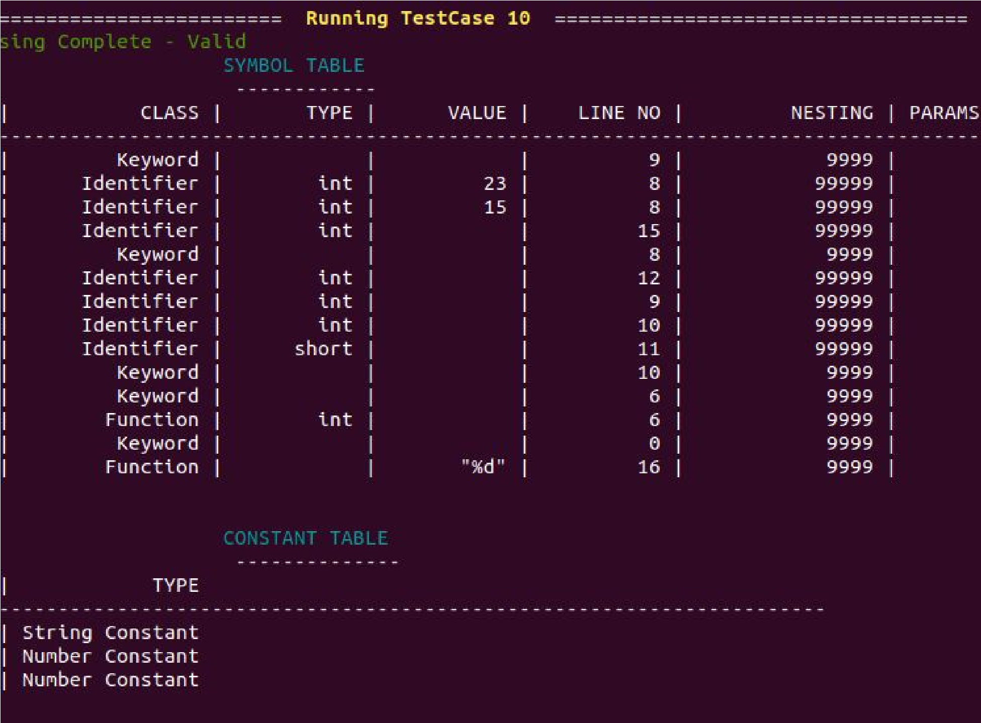

Fig. 3.

**Status : PASS**

## Invalid Test Cases

Test Case 1: Function not declared

**Output:**



Fig.4.

**Status : PASS**

Test Case 2: Function of type void

**Output:**



Fig. 5

**Status : PASS**

Test Case 3: Unmatched number of arguments Output:

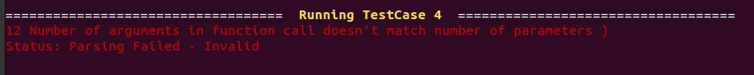

Fig. 6

**Status : PASS**

Test Case 4: Type mismatch

**Output:**



Fig. 7

**Status : PASS**

Test Case 5: Wrong Array Size

**Output:**



Fig. 8

**Status : PASS**

References:

1. Compilers: Principles, Techniques, and Tools: Alfred V. Aho, Monica S. Lam, Ravi Sethi, and Jeffrey D. Ullman